Step 1 <http://dslookup.instwall.com/>

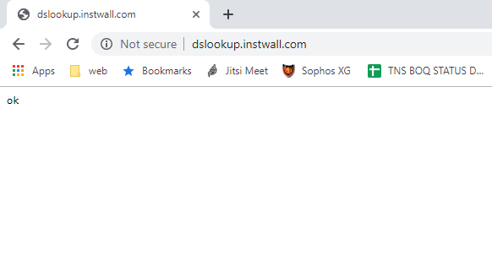

Step 2 <http://dslookup.instwall.com:20060>

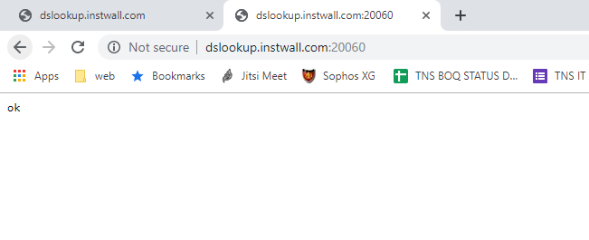

Step 3 <http://dslookup.instwall.com:20061>

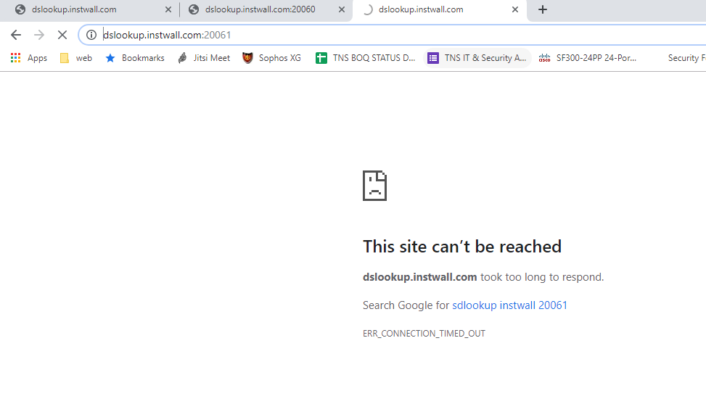

1. Open the browser and access following the websites.
   * 1. [http://dscloud.instwall.com](http://dscloud.instwall.com/)

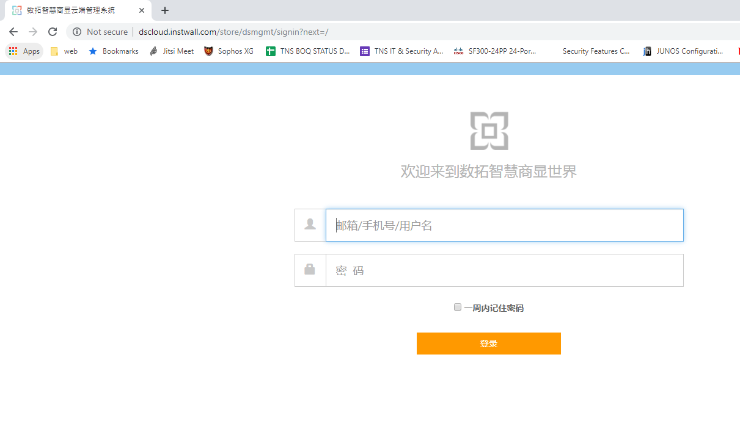

* + 1. <https://dscloud.instwall.com/api/json>

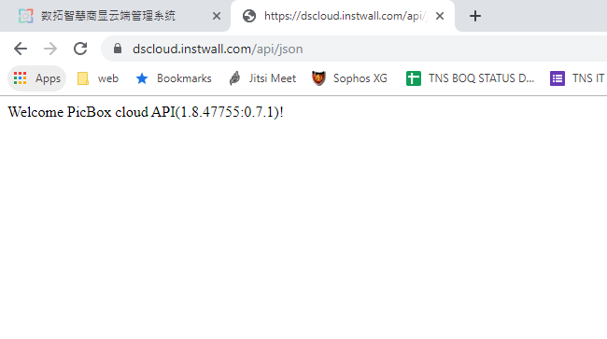

4.Open the browser and access following the websites.

1- [https://dsauth.instwall.com](https://dsauth.instwall.com/)

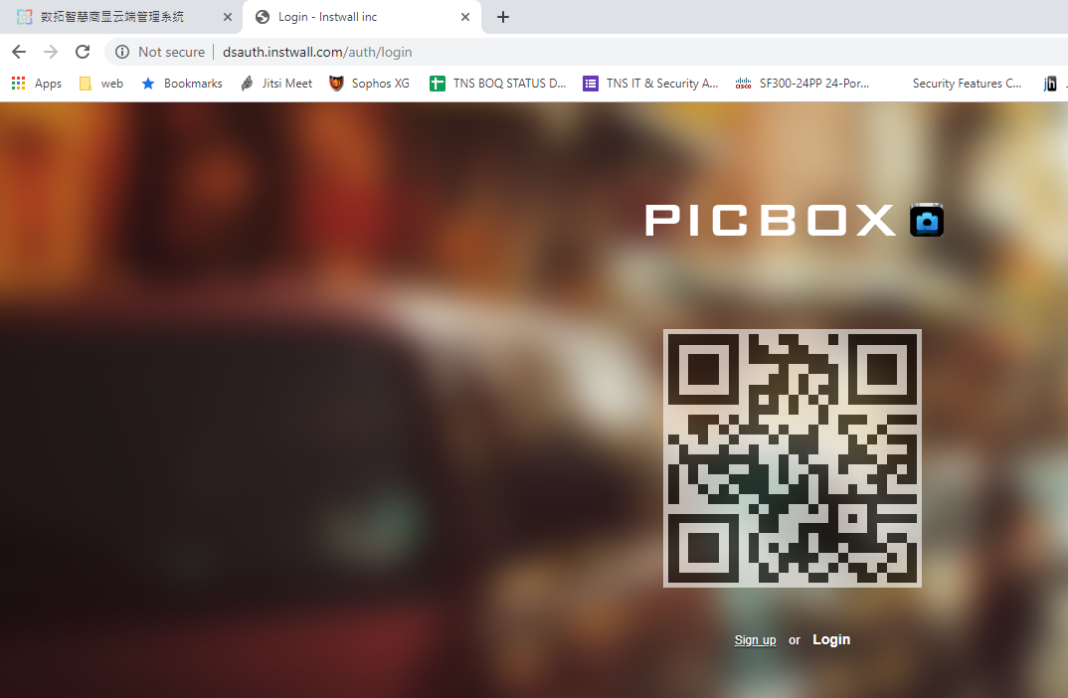

5.Open the browser and access following the websites.

1:- [http://oss-cn-hangzhou.aliyuncs.com](http://oss-cn-hangzhou.aliyuncs.com/)

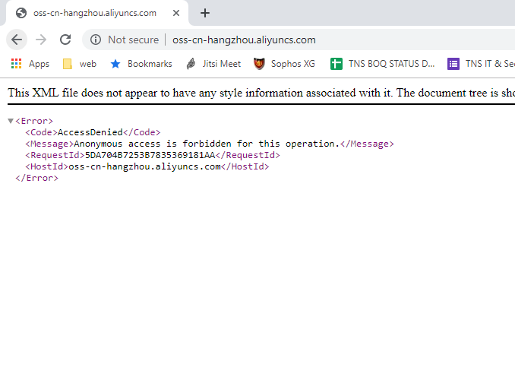

1. Installing the telnet command tools or using the default telnet commandin windows. We also provide thedownload linkhere. (<http://www.instwall.com/apk/telnet.exe>), just double click this link you can get it.
   1. Input “open dim.instwall.com 5222”and enter

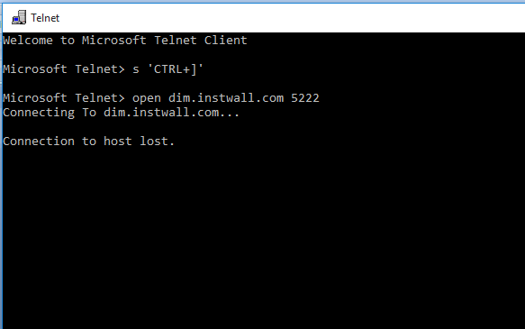

3:- open dim.instwall.com 443

